Laser Creations
Student Resource:
The best way to describe how CO2 laser cutter/engravers work is to compare the system to your printer. Using similar technology, a laser cutter/engraver takes the images you typically print to paper, but instead of ink, a CO2 laser beam is fired, and that beam actually burns the image you select to etch/engrave, or cut.

The laser recognizes images, graphics, text, and lines, and through your graphic design software and print driver, you instruct the laser on which items to engrave, and which ones you want to cut.

The laser works in three different modes: raster, vector, and combined.
Raster Mode: We use raster mode when we want to engrave or etch. Most users engrave clipart, scanned images, photos, text, and graphic images.

Vector Mode: Use vector mode when you are cutting lines. In vector mode, a line is recognized as a line to be cut based on the line width (or stroke). To make things easy, set any cut lines to a line width of 0.001” (.0254 mm), or hairline width in CorelDRAW. Vector lines that you want to engrave rather than cut should be set 0.006” (0.152 mm) or greater line thickness.

Combined Mode: Use this setting when you engrave and cut in the same job. The laser will always engrave first, and then follow with the vector cutting path.

Let’s start with a simple project – a wooden identification tag you can adhere to your backpack or luggage. Use the student worksheet to walk you through the steps of designing your custom tag and using the laser to engrave and cut it!

Laser Creations
Student Worksheet:
Open a new file in CorelDRAW.

Under “page size”, enter the size of the wood plank you will be working with. For the purposes of this tutorial, we used 14” x 4.5”, but your page size may be different.
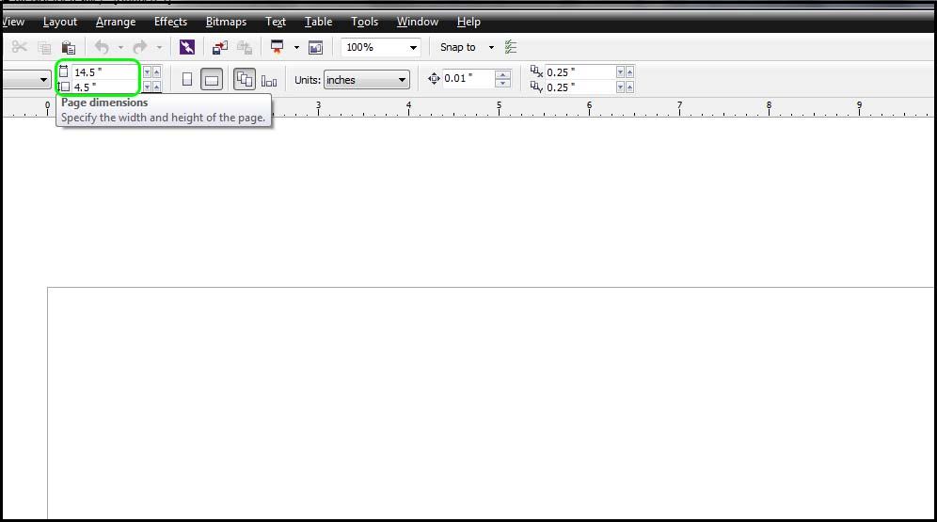

Using the Rectangle Tool, draw your luggage tag – we suggest a size of 2” x 4” or 3” x 5”, depending on the size of your wood plank.

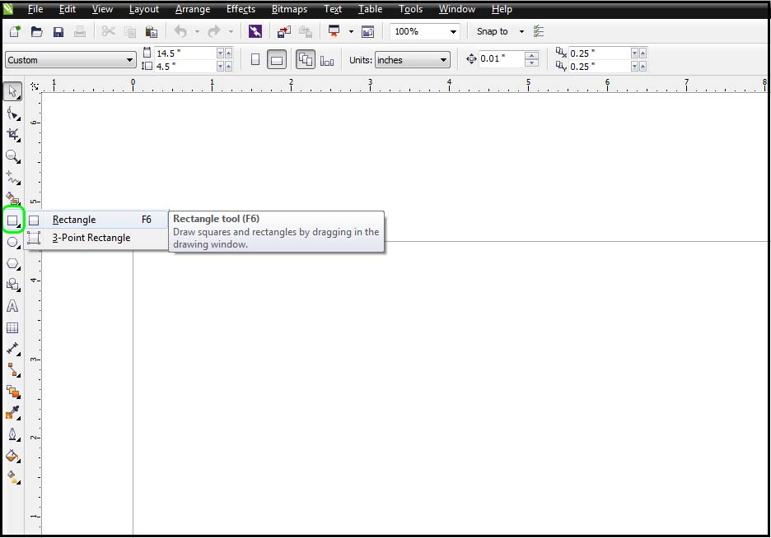

Make sure your tag is set to a line weight of “hairline.”

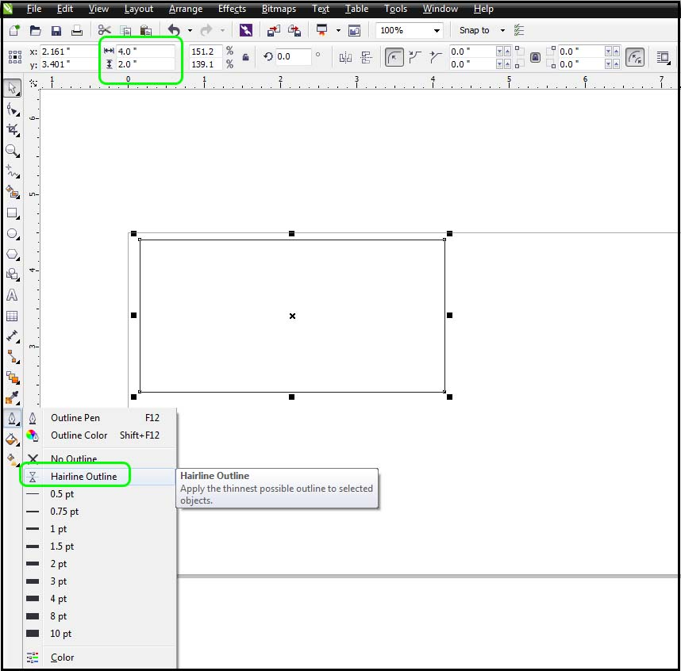

We need to add a circle cut-out that will allow you to place a ring or string to attach the tag to your bag. Use the Ellipse Tool to create a small hole – about ¼” in diameter. Remember to change the outline to “hairline” so it will cut out.

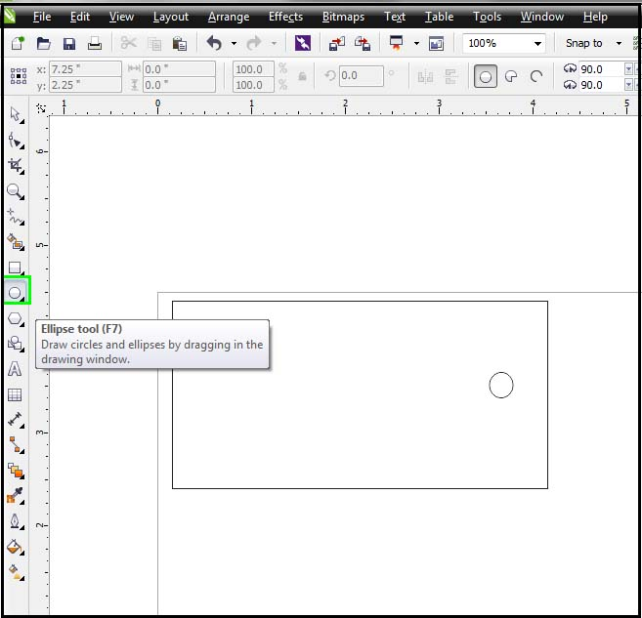

After you’ve drawn your square tag and cut-out hole, use the text tool to enter the contact information you want to include, such as your name and email address.
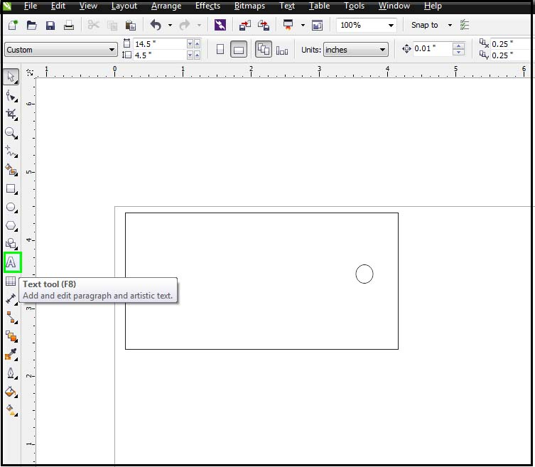

Select your font and size to best fit on the tag.
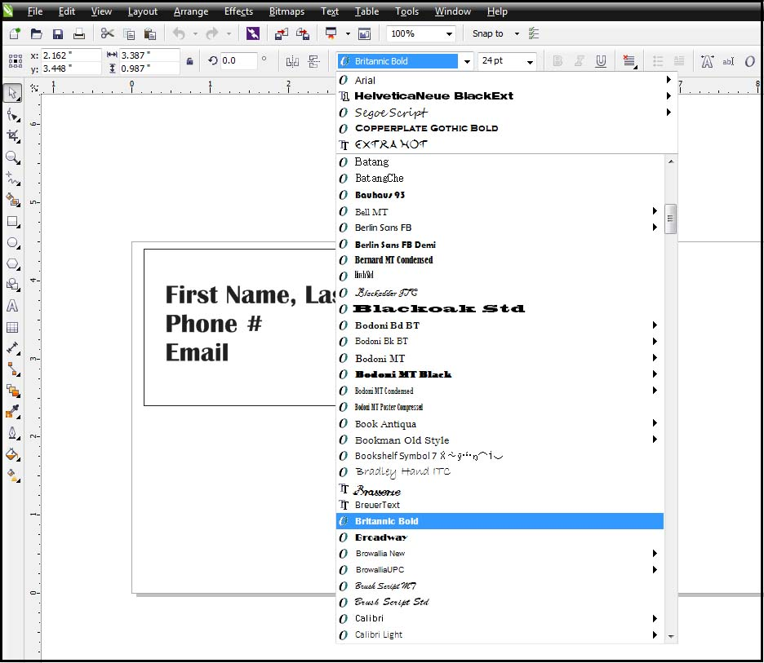

When you’re ready to engrave and cut your tag, hit “CTRL P” and send your job to the laser. When the print driver pops up, change the piece size to match what you entered in CorelDRAW. Change your raster engraving settings and vector cutting settings (refer to user manual for recommended settings for your wattage laser). Lastly, make sure you have “combined mode” selected in the print driver, since you want to both engrave and cut.
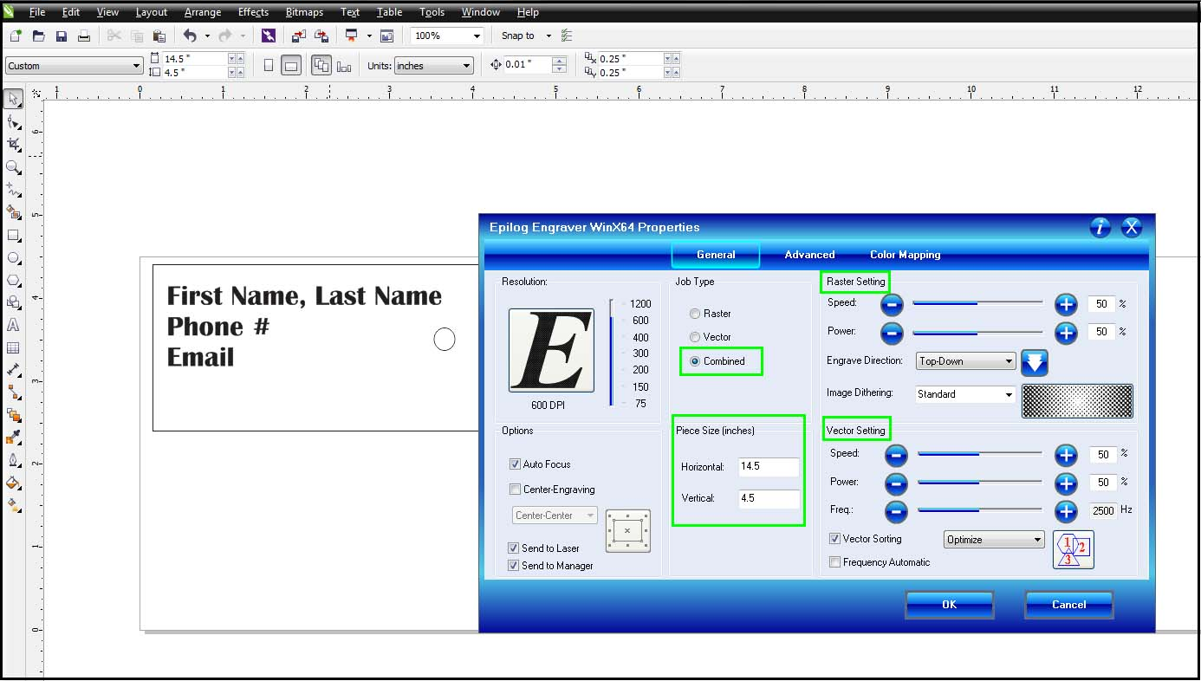

When the job reaches the laser, press the green “GO” button and your tag will be made.
After you’ve created your own tag with the instructions above, experiment with different shapes, text, and fonts to create a new tag for a friend or family member!

