

IEEE Lesson Plan:
Making a Motor Shield
Sponsored by Digi-Key Electronics

Explore other TryEngineering lessons at www.tryengineering.org

Lesson Focus

This lesson, sponsored by Digi-Key Electronics, explores the power of a microcontroller by having students add a motor shield to an Arduino board and test its ability to control various motors that can be used in robotics and mechatronics projects.

Lesson Synopsis
Introduce students to:
- Concept of using a motor shield to control motor speed and direction.
- Using online software library to install code.
- Testing various types of motors.

Age Levels
Ages 12-18

Objectives
Introduce students to:
- Concept of using a motor shield to control motor speed and direction.
- Using online software library to install code.
- Testing various types of motors.

Anticipated Learner Outcomes
As a result of this activity, students will be able to:
- Install and operate a motor shield using the Adafruit Motor Shield kit and motors as provided.
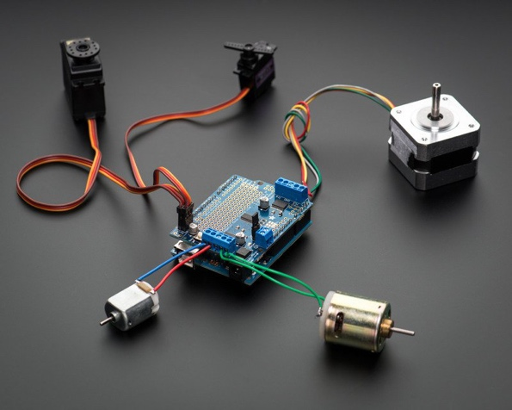
Lesson Activities

Student learn how to add a motor shield to an Arduino board, testing its ability to control various motors that can be used in robotics and mechatronics projects.

Resources/Materials

- Teacher Resource Documents (attached)
- Student Resource Sheet (attached)
- Student Worksheet (attached)

Alignment to Curriculum Frameworks

See attached curriculum alignment sheet.

Internet Connections

- TryEngineering
- Adafruit Motor Shield V2
- Adafruit Motor Shield V2 Arduino Library
- Wikipedia: Stepper motor
- Wikipedia: Servomotor

Recommended Reading

- University of Iowa Dept. of Computer Science: Control of Stepping Motors tutorial

Optional Writing Activity

- Write an essay (or paragraph depending on age) describing how the invention of microcontrollers have impacted the design of everyday products. Consider the difference between microprocessors and microcontrollers and their use in robotics and mechatronics.

IEEE Lesson Plan:
Making a Motor Shield

For Teachers:
Teacher Resource

Part 1: Installing Headers and Terminals

- Lesson Objectives
Students will learn how to:
- Install standard or stacking headers
- Install terminal blocks
- Make servo connections

- Materials
For each student or student team:
- Arduino UNO board
(NOTE: In addition to working with all revisions of the Arduino UNO board, the shield is also tested to work with Duemilanove, Diecimila, Leonardo and Mega/ADK R3 and higher. It can also be adapted to work with Mega R2 and lower.)
- Adafruit Motor Shield kit (version 2)
- Stacking headers (optional; available separately)
- Soldering iron and solder
- Student Resource Sheets
- Student Worksheets

- Time Needed: 30 minutes to 1 hour (depending on soldering skills)

- Procedure

- Installing standard headers
Note: The shield comes with a 0.1 in standard header. Standard headers do not permit stacking, but they are mechanically stronger and less expensive than stacking headers. With standard headers, the shield allows the use of two DC hobby servos that run on 5 V, and up to four DC motors, or two stepper motors, or one stepper motor and up to two DC motors that run on 5 – 12 V DC.
Stacking shields on top allows more motors to be connected. Each stacked shield (maximum of 32) adds an additional four DC motors, or two stepper motors, or one (1) stepper motor and two (2) DC motors. If stacking shields on top, do not perform Step A as it is not possible to uninstall headers once soldered in. Skip to Step B instead.
Each student or student team will perform the following steps.
  - Break apart the 0.1 in header into 6-, 8- or 10-pin-long pieces and slip the long ends into the headers of their Arduino boards.
  - Place the assembled shield on top of the headered Arduino so that all the short parts of the header are sticking through the outer set of pads.
  - Solder each one of the pins into the shield to make a secure connection. When finished, skip to Step C to install terminal blocks.
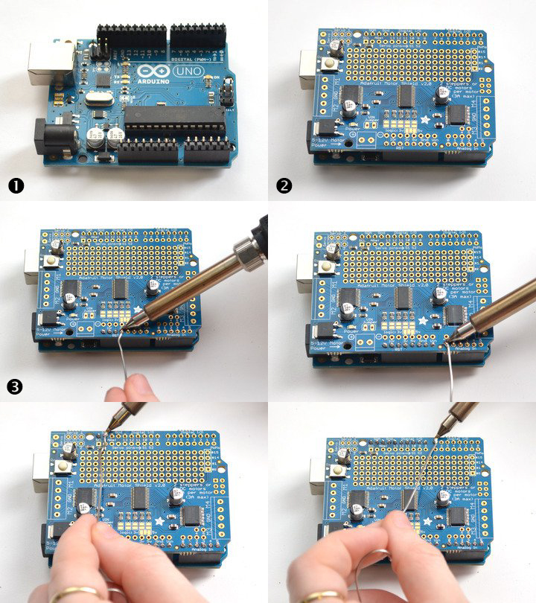

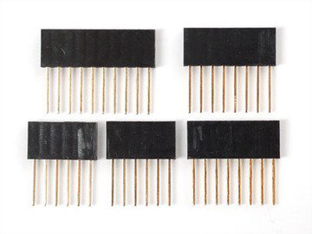
- Installing stacking headers
Note: As noted above, this is an alternate header installation that will permit stacking. Arduino stacking headers are available separately; the motor shield kit does not come with them. Each shield to be stacked, except the top shield, must have stacking headers installed.

Each student or student team will perform the following steps.

  - Slide the 10-pin, 2 x 8-pin and 6-pin stacking headers into the outer rows of the shield from the top. Then flip the board over so it is resting on the four headers.
Tip: If necessary, pull on the legs to straighten them out.
Arduino stacking headers
are available separately.
  - Tack one pin of each header to get them set in place before soldering.
Tip: If the headers get crooked, one pin can be re-heated and re-positioned to straighten them up.
  - Once all the headers have been tacked and straightened, go back and solder the remaining pins for each header.
Tip: Though not shown below, the 2 x 3 stacking header should be soldered in as well. Even though this shield does not use it, the one above may need those pins.

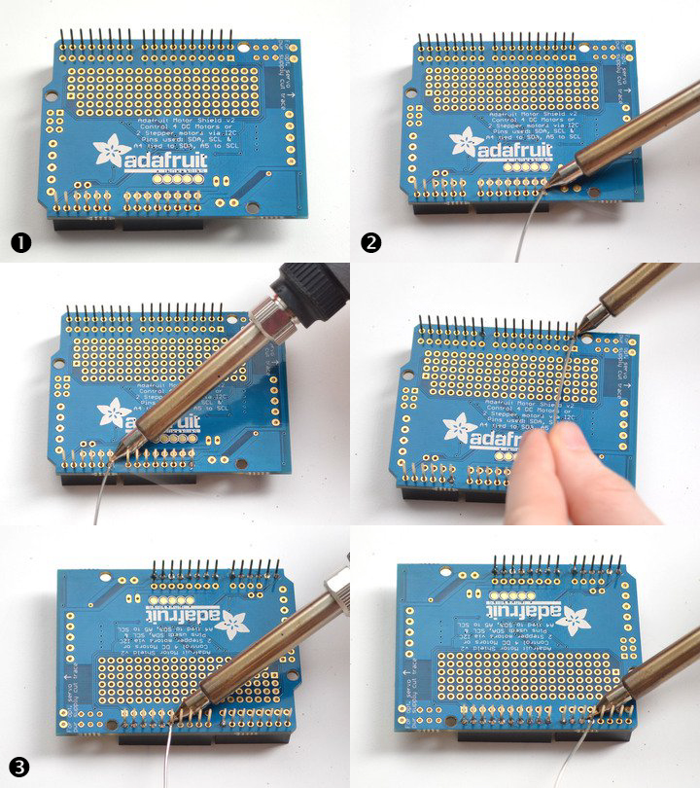

- Installing terminal blocks
Note: This step follows installation of either normal headers (Step A) or stacking headers (Step B). Terminal block installation will allow power and motors to be connected to the shield without the need for soldering.
Each student or student team will perform the following steps:

  - Slide the 3-pin terminal blocks into 2-pin terminal blocks to create 2 x 5-pin and 1 x 2-pin blocks.
Tip: The two 5-pin sets go on either side. The 2-pin piece goes near the bottom of the shield. The open holes of the terminal blocks should be facing out.
  - Flip the board over and solder the pins of the terminal blocks.
  - Solder in the two pins of the external power terminal block.
  - Solder in both motor blocks (5 pads each).

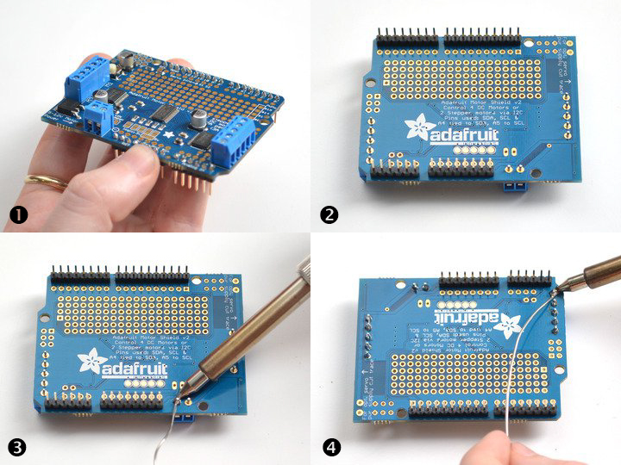

- Making servo connections
Each student or student team will perform the following steps.

  - Place the 2 x 3-pin header, short legs down, into the top corner where it says Servo 1 and Servo 2.
Tip: The part may need to be slightly angled to fit into both sets of 3-pin holes. This is an intentional part of the design that helps keep the header in place.
  - Flip the board over and solder the 6 pins
  - Break off a 2-pin piece of header and place it next to the power terminal block, short legs down. If necessary, tape it in place. Solder it in.

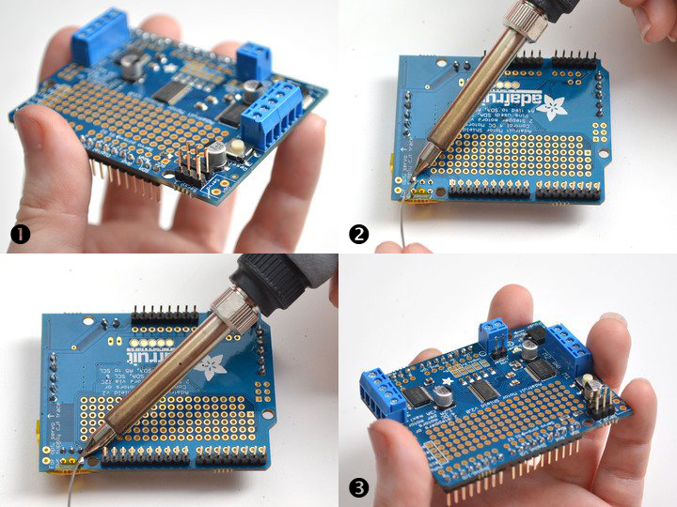

Part 2: Installing Software

Teacher Resource

Anticipated Learner Outcomes
Students will be able to:
- Use online software library to install code.
- Install software that enables motor control.

Materials
For each student or student team:
- Adafruit Motor Shield kit (version 2)
- Internet connection

- Time Needed: 30 minutes to 1 hour (Depending on new to IDE Arduino software)

Procedure
Installing Adafruit Motor Shield v2 library
NOTE: The Adafruit Motor Shield v2 library is required. This library is not compatible with the older AF Motor library, which was used for v1 shields and did not support shield stacking. However, code for the older shield can be adapted for the new shield. This detailed tutorial provides more information on installing Arduino libraries.

Each student or student team will perform the following steps:
  - Install the Adafruit_Motor_Shield_V2_Library, available on Adafruit’s github repository.
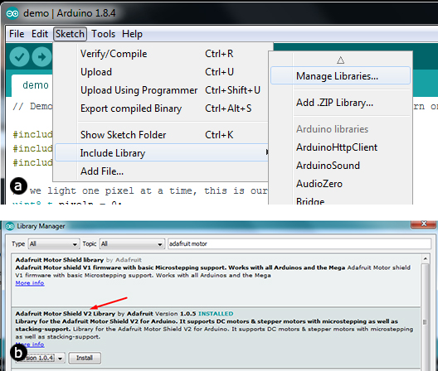
Tip: Using the Arduino library manager is recommended; follow the steps below to use.
    - From the integrated development environment (IDE), open the library manager.
    - Type in “adafruit motor” to locate the library.
    - Click Install.

  - (Optional) To use AccelStepper for acceleration control or for simultaneous control of multiple stepper motors, download and install the AccelStepper library.

Part 3: Running the example code

Teacher Resource

Anticipated Learner Outcomes
Students will be able to:
- Use the motor shield to control motors as provided.

Materials
For each student or student team:
- Adafruit Motor Shield kit (version 2)
- Internet connection
- DC motor (optional for Step A; available separately)
- Stepper motor (optional for Step B; available separately)

Note: Several motors are available. Adafruit’s motor party add-on pack offers an assortment of DC, stepper and servo motors.

- Time Needed: 30 minutes to 1 hour (Depending on new to IDE Arduino Software)

Procedure
- DC motor test
Note: The code will work with any DC motor that can be powered by 5 to 12 V DC.
Each student or student team will perform the following steps:

  - Restart the IDE to make sure the new library is loaded.
  - Plug the shield into the Arduino and connect a DC motor to motor port 1.
Tip: It does not matter which wire goes into which terminal block, as motors are bi-directional.
  - Connect to the top two terminal ports. Do not connect to the middle pin, which is a ground (GND).
Tip: See the photo below for the red and blue wire example. Students should be sure to screw down the terminal blocks to make good connections.

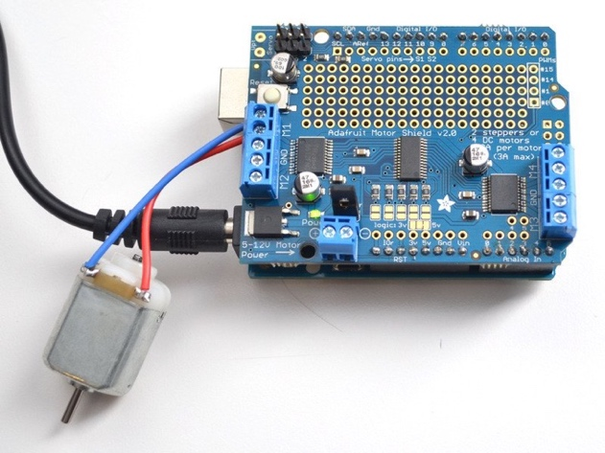
  - Supply 5 – 12 V DC to power the motor, using one of two methods.
    - Use the DC barrel jack to power the Arduino. Insert the VIN jumper (shown as the tall black handle right next to the green power LED in the photo below).
-or-
    - Use the DC barrel jack or USB port to power the Arduino, then use the 5 – 12 V DC motor power terminal port (shown as the double terminal block next to the green power LED) to power the shield. Remove the VIN jumper.
Note: If the green power LED next to the power terminal block isn't brightly lit, students should not continue!

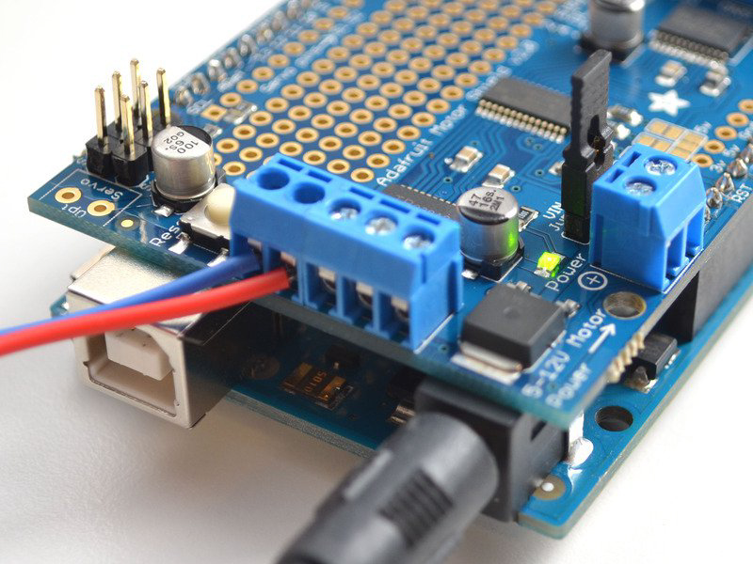
  - After verifying that the motor is connected properly with the power LED brightly lit, upload the DC motor test code.
    - In the IDE, load File -> Examples -> Adafruit_MotorShield -> DCMotorTest
Tip: Students should see and hear the DC motor turn on and move back and forth. If they have trouble seeing the movement, attaching a slip of paper or tape can help them visualize it.
- Stepper motor test

Note: The shield can run unipolar (5-wire and 6-wire) and bipolar (4-wire) steppers, using the same code. It cannot run steppers with any other number of wires.
Each student or student team will perform the following steps.

  - Restart the IDE to make sure the new library is loaded.
  - Plug the shield into the Arduino and connect a stepper motor to motor port 2. Tip: Note that, unlike DC motors, the wire order does matter.

  - Connect to the top two terminal ports (coil #1) and the bottom two terminal ports (coil #2).
    - For a bipolar motor, do not connect to the middle pin (GND).
    - For a unipolar motor with 5 wires, connect the common wire to GND.
    - For a unipolar motor with 6 wires, connect the two “center coil wires” together to GND.
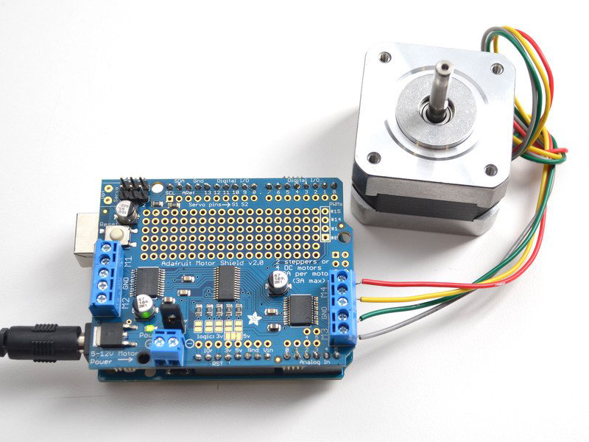

  - Supply 5 – 12 V DC to power the motor, using one of two methods:

    - Use the DC barrel jack to power the Arduino. Insert the VIN jumper (shown as the tall black handle right next to the green power LED in the photo below).
-or-
    - Use the DC barrel jack or USB port to power the Arduino, then use the 5 – 12 V DC motor power terminal port (shown as the double terminal block next to the green power LED) to power the shield. Remove the VIN jumper.

NOTE: If the green power LED next to the power terminal block isn't brightly lit, students should not continue!

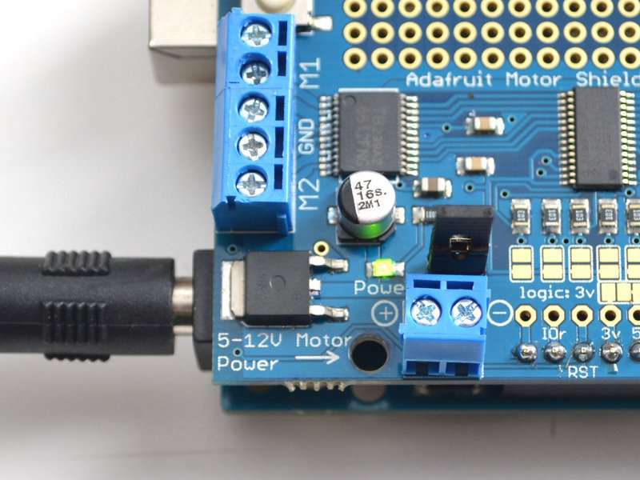
  - After verifying that the motor is connected properly with the power LED lit up brightly, upload the stepper motor test code.
    - In the IDE, load File -> Examples -> Adafruit_MotorShield -> StepperTest
Tip: Students should see and hear the stepper motor turn on and move back and forth. If they have trouble seeing the movement, attaching a slip of paper or tape can help them to visualize it. There are four ways to move a stepper, with varying speed, torque and smoothness tradeoffs. This example code will demonstrate all four.

IEEE Lesson Plan:
Making a Motor Shield

For Teachers:
Teacher Resource

Additional tips
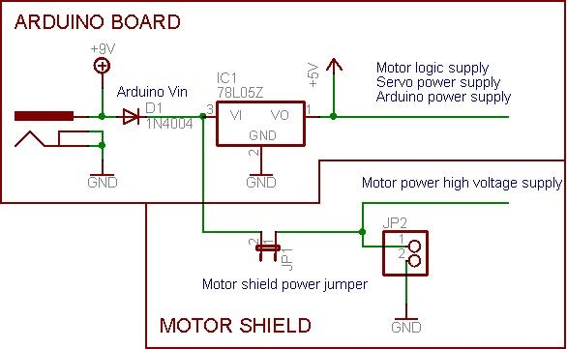

- Voltage requirements
  - Determine what voltage the motors will use. Some, though not all, come with specifications.
  - Note that the motor controllers on this shield are designed to run from 5 – 12 V; most 1.5 – 3 V motors will not work.
- Current requirements
  - Determine how much current the motors will require.
  - Note that the motor driver chips that come with the kit are designed to provide up to 1.2 A per motor, with 3 A peak current.
Tip: Note that once you approach 2A you'll want to put a heat-sink on the motor driver to avoid thermal failure and possible burn-out of the chip.
  - Motors cannot be run with a 9 V battery. Use a large lead-acid or NiMH battery pack. For best results, set up two power supplies (split supply): one for the Arduino board and another for the motors.
Tip: Most weird motor problems are due to noise on the power line from sharing power supplies or not having a powerful enough supply. Even small DC motors can draw up to 3 A when they stall.

- Power supply options
  - Using a single DC power supply
    - To use a wall adapter or single battery pack with 5 to 12 V DC output to power both the Arduino board and the motors, plug it into the Arduino’s DC jack or the 2-pin power terminal block on the shield.
Tip: The drawback of this setup is that the Arduino may reset if the battery supply is not able to provide constant power. Note that a 9 V battery cannot be used; a single/double lead-acid battery pack or 4 to 8 AA batteries are required.

  - Using USB for Arduino and DC power supply for motors (recommended)
    - Plug in the USB cable.
    - Connect the motor supply to the power terminal block on the shield. Do not place the jumper on the shield.
Tip: This is the recommended method for powering the motor project because it offers a split supply: one power supply for logic, and another for the motors.

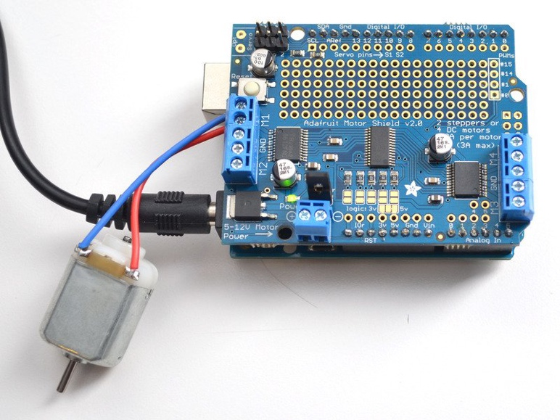
  - Using two separate DC power supplies
    - Plug the Arduino supply into the DC jack.

    - Connect the motor supply to the power terminal block.
    - Ensure that the jumper is removed from the motor shield.

- Powering DC motors
Tip: DC motors are used for all sorts of robotic projects. The motor shield can drive up to four DC motors bi-directionally (i.e., forwards and backwards). The speed can also be varied at 0.5% increments using the built-in pulse width modulation (PWM), which provides for smooth consistency. Check motor data sheets to verify compatibility; the H-bridge chip is designed to drive small motors as opposed to continuous loads of 1.2 A.
  - DC motors are powered with a high-voltage supply as opposed to the regulated 5 V used by the Arduino board.
  - This supply can come from the Arduino DC barrel jack, or from the 2-terminal block on the shield labeled “DC Motor Power 5-12VDC.”
Note: Connecting the motor power supply to the Arduino's 5 V power pin could damage the Arduino or USB port. The Arduino’s DC jack has a protection diode to minimize damage if the wrong type of power is plugged in. Likewise, the terminal block has a protection field-effect transistor (FET) for avoiding damage to either the Arduino or the motor shield if the battery supply wires are backward.

  - To connect a motor, solder two wires to the terminals and then connect them to either M1, M2, M3 or M4.
  - Using the Adafruit_Motor_Shield_V2_Library
    - Include the required libraries, as shown below:
#include <Wire.h>
#include <Adafruit_MotorShield.h>
#include "utility/Adafruit_MS_PWMServoDriver.h"

    - Create the Adafruit_MotorShield object.
Adafruit_MotorShield AFMS = Adafruit_MotorShield();
    - Create the DC motor object.
      - Request the DC motor from the Adafruit_MotorShield with getMotor(port#) where port# corresponds to which port it is connected to; M1=1, M2=2, M3=3, M4=4.
Adafruit_DCMotor *myMotor = AFMS.getMotor(1);
    - Connect to the controller.
      - In the setup() function, call begin() on the Adafruit_MotorShield object:
AFMS.begin();

    - Set default speed.
      - Set the speed of the motor using setSpeed(speed) where speed ranges from 0 (stopped) to 255 (full speed).
myMotor->setSpeed(150);
    - Run the motor.
      - To run the motor, call run(direction) where direction is FORWARD, BACKWARD or RELEASE.
myMotor->run(FORWARD);
Tip: The Arduino doesn't actually know if the motor is going forward or backward, so swapping the two wires from the motor to the shield will reverse these directions.
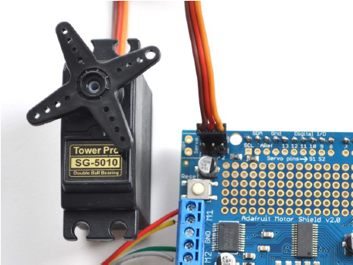
- Powering RC (hobby) servos
Tip: Hobby servos are the easiest way to get going with motor control. They have a 3-pin 0.1 in female header connection with 5 V ground and signal inputs. The motor shield brings PWM output lines from Arduino pins 9 and 10 to two 3-pin headers to make it easy to plug in and go.
  - Servos are powered with Arduino’s on-board 5 V regulator, directly from the USB or DC power jack.
Tip: Servos consume a lot of power, so a 9 V battery won’t last more than a few minutes.
  - An external supply can also be used for more power, using the steps below.
Note: This is for advanced users only! The servos can be destroyed if the power supply is incorrectly connected.
    - Cut the 5 V trace on the bottom of the Arduino board.
    - Insulate the top of the USB socket on the processor board with electrical tape to avoid the power supply shorting out against the socket shell.
    - Connect a 5 or 6 V DC supply directly to the Opt Servo power input.
  - For official documentation on using servos, refer to Arduino’s servo library.

- Using stepper motors
Tip: Stepper motors are great for semi-precise control, which is perfect for many robot and CNC projects. Running a stepper is a little more intricate than running a DC motor, but still very easy. The motor shield supports up to two stepper motors, and the library works identically for bipolar and unipolar motors.

  - Unipolar motors
    - To connect the stepper, first determine which pins connect to which coil, and which pins are the center taps. 5-wire motors will have one pin that is the center tap for both coils.
Tip: There are plenty of tutorials online on how to reverse engineer the coils pinout.
    - The center taps should both be connected to the GND terminal on the motor shield output block. Coil 1 should connect to one motor port (M1 or M3) and coil 2 should connect to the other motor port (M2 or M4).
  - Bipolar motors
    - The same steps for unipolar motors apply, except that there is no fifth wire to connect to the GND. The code is identical.

  - Using the Adafruit_Motor_Shield_V2_Library
    - Include the required libraries, as shown below:
#include <Wire.h>
#include <Adafruit_MotorShield.h>
#include "utility/Adafruit_MS_PWMServoDriver.h"

    - Create the Adafruit_MotorShield object.
Adafruit_MotorShield AFMS = Adafruit_MotorShield();
    - Create the stepper motor object.
      - Request the stepper motor from the Adafruit_MotorShield with getStepper(steps, stepper#) where steps indicates how many steps per revolution the motor has and stepper# corresponds to which port it is connected to; M1 and M2=port 1, M3 and M4=port 2.
Tip: To calculate the value for steps, divide the number of degrees the motor turns with each step into 360. For example, a motor that turns at 7.5 degrees per step has a steps value of 48 (360/7.5).
Adafruit_StepperMotor *myMotor = AFMS.getStepper(200, 2);
    - Set default speed.
      - Set the speed of the motor using setSpeed(rpm) where rpm is how many revolutions per minute the stepper will turn.
    - Run the motor.
      - For each movement of the motor, call the step(#steps, direction, steptype) procedure where #steps is how many steps the motor will take, direction is either FORWARD or BACKWARD, and steptype is SINGLE, DOUBLE, INTERLEAVE or MICROSTEP.
Note: Single means single-coil activation. Double means two coils are activated at once, which produces higher torque. Interleave alternates between single- and double-coil activation, which produces twice the resolution but half the speed. Microstep uses PWM to create smooth motion between steps. Any stepping method can be used and changed on the fly to offer variations in power, torque and precision. The resources page has information about the pros and cons of these different stepping methods.
By default, the motor will hold its position after it has completed stepping. The motor needs to be instructed each time movement is desired. The AccelStepper library offers examples for controlling three steppers simultaneously, with varying acceleration.
      - To release all coils and allow the motor to spin freely, call release().
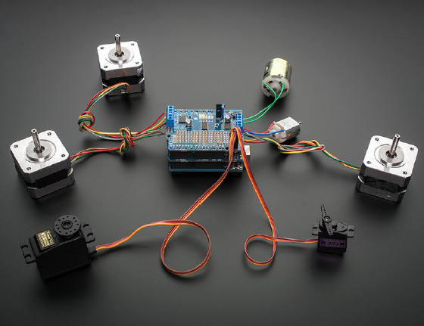
- Stacking shields
Note: Refer to Lesson 1 above for more information on stacking shields, which allows more motors to be connected. Each stacked shield adds an additional four DC motors, or two stepper motors, or one stepper motor and two DC motors. Up to 32 shields can be stacked, for a total of 64 steppers of 128 DC motors.
Each shield to be stacked, except the top shield, must have stacking headers installed. Arduino stacking headers are available separately; the motor shield kit does not come with them. The top shield does not require stacking headers, unless there will eventually be something on top of it.
Because servos are hard-wired to Arduino pins 9 and 10, stacking shields does not increase servo connections. It is possible to control up to 16 servos with Adafruit’s 16-channel servo shield, available separately.

Each stacked shield also must have a unique I2C address; refer to the steps below for more information.

  - Assigning shield addresses
Note: Each stacked shield must have a unique I2C address. The default I2C base address for each board is 0x60; a total of 32 unique binary addresses, ranging from 0x60 to 0x7F, can be assigned.

    - Addresses are assigned with the address jumpers on the lower edge of the board.
    - To program the address offset, use a drop of solder to bridge the corresponding address jumper for each binary 1 in the address.
Note: The right-most jumper is address bit #0. The number increases by 1 as the jumpers are read from right to left (i.e., address bit #1 is to the left of address bit #0, address bit #2 is to the left of address bit #1, and so on up to address bit #4).
Board 0: Address = 0x60 Offset = binary 0000 (no jumpers required)
Board 1: Address = 0x61 Offset = binary 0001 (bridge A0, as in the photo below)
Board 2: Address = 0x62 Offset = binary 0010 (bridge A1, to the left of A0)
Board 3: Address = 0x63 Offset = binary 0011 (bridge A0 & A1, two right-most jumpers)
Board 4: Address = 0x64 Offset = binary 0100 (bridge A2, middle jumper)

Tip: Address 0x70 is the "all call" address for the controller chip on the shield. All boards will respond to address 0x70 regardless of address jumper settings.

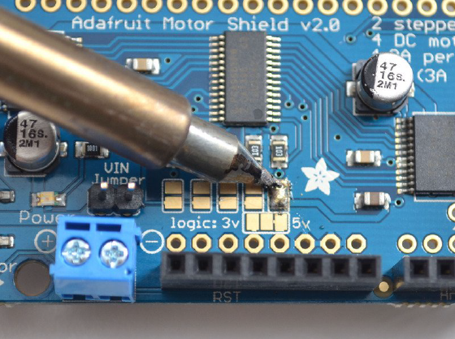

  - Writing code for multiple shields
Note: Unlike the older AF_Motor library, the Adafruit_MotorShield library can control multiple shields.
    - Create a motor shield controller for each shield, with the assigned address.
Adafruit_MotorShield AFMSbot(0x61); // Rightmost jumper closed
Adafruit_MotorShield AFMStop(0x60); // Default address, no jumpers
Tip: For the sake of organization, use AFMSbot for the bottom shield and AFMStop for the top shield. Specify these addresses when creating the shield object.

    - Request the motors connected to each shield.
// On the top shield, connect two steppers, each with 200 steps
Adafruit_StepperMotor *myStepper2 = AFMStop.getStepper(200, 1);
Adafruit_StepperMotor *myStepper3 = AFMStop.getStepper(200, 2);
// On the bottom shield connect a stepper to port M3/M4 with 200 steps
Adafruit_StepperMotor *myStepper1 = AFMSbot.getStepper(200, 2);
// And a DC Motor to port M1
Adafruit_DCMotor *myMotor1 = AFMSbot.getMotor(1);

Tip: A stepper or DC motor can be requested from any port as long as the correct AFMS controller object is specified when getMotor or getStepper is called.

    - Both shields must have begin called before connected motors can be used.
AFMSbot.begin(); // Start the bottom shield
AFMStop.begin(); // Start the top shield

Tip: This code can be tested by setting up two shields and running the File -> Examples -> Adafruit_MotorShield -> StackingTest example.

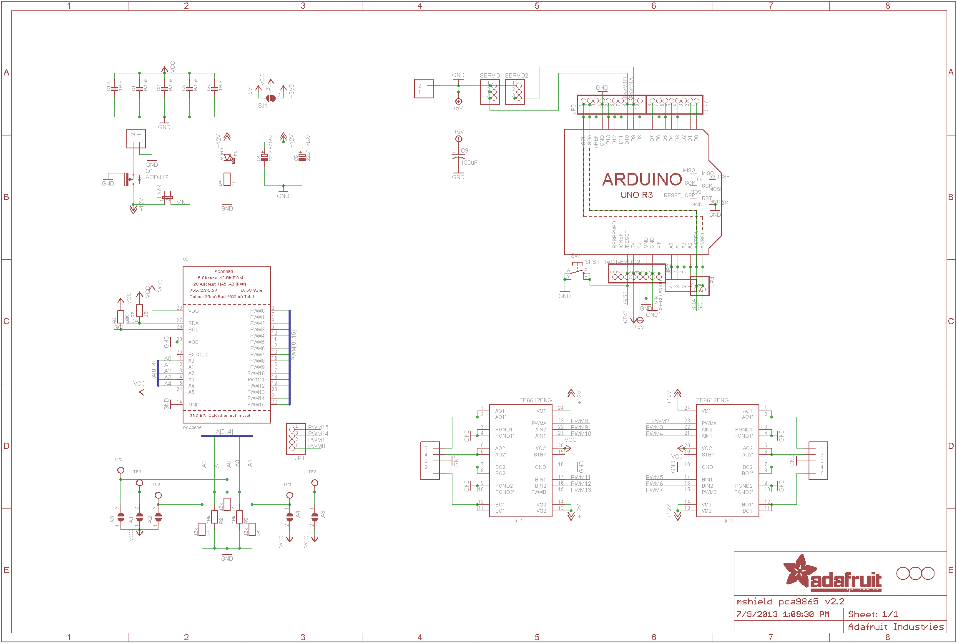
Arduino UNO R3 schematic. For a larger version, click here.

IEEE Lesson Plan:
Making a Motor Shield

Student Resource:
Why use a Motor Shield?

The Adafruit Motor Shield is a great and quick way to control DC motors, servos or even stepper motors to be used in robotics and mechatronics projects.
DC Motors
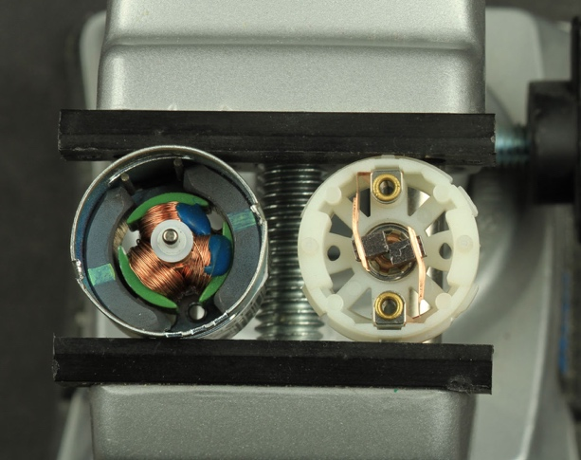
Brushed DC motors are probably the most common type of motor there is. These motors can be found in everything from hand-held fans and cordless drills, to cell phone buzzers and steel mills. These motors are used to power cars and trains, and not just the toy ones! They use brushes that rub on a segmented copper ring so that the current through the armature coils alternates as the motor spins. We opened one up in the photo to the right, so you can see the magnets and coils in the left and the spring-loaded brushes on the right. DC motors are available in a wide variety of sizes, ranging from tiny motors for miniature devices up to and including large industrial motors capable of many horsepower. Check out the Motor selection guide: https://learn.adafruit.com/adafruit-motor-selection-guide

Servos
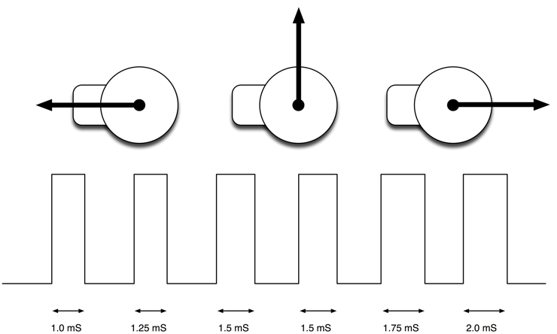
Servo motors are controlled by pulses of varying lengths and have a back and forth motion. The position of the servo motor is set by the length of a pulse. The servo expects to receive a pulse roughly every 20 milliseconds. If that pulse is high for 1 millisecond, then the servo angle will be zero, if it is 1.5 milliseconds, then it will be at its center position and if it is 2 milliseconds it will be at 180 degrees. Watch this short video on what is inside a servo motor: https://learn.adafruit.com/adafruit-arduino-lesson-14-servo-motors/inside-a-servo

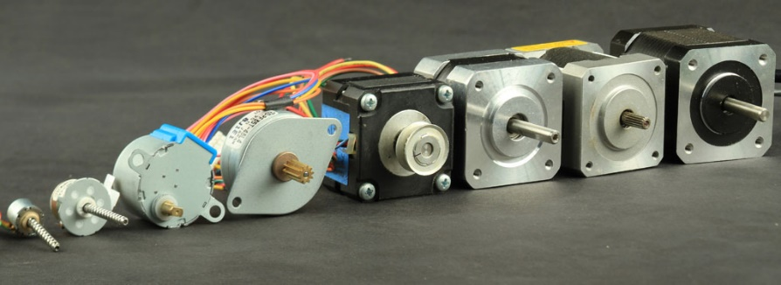
Stepper Motors
Stepper motors are DC motors that move in discrete steps. They have multiple coils that are organized in groups called "phases". By energizing each phase in sequence, the motor will rotate, one step at a time. With a computer controlled stepping you can achieve very precise positioning and/or speed control. For this reason, stepper motors are the motor of choice for many precision motion control applications. Stepper motors come in many different sizes and styles and electrical characteristics. This guide details what you need to know to pick the right motor for the job. Stepper motors are good for:
- Positioning – Since steppers move in precise repeatable steps, they excel in applications requiring precise positioning such as 3D printers, CNC, Camera platforms and X,Y Plotters. Some disk drives also use stepper motors to position the read/write head.
- Speed Control – Precise increments of movement also allow for excellent control of rotational speed for process automation and robotics.
- Low Speed Torque - Normal DC motors don't have very much torque at low speeds. A Stepper motor has maximum torque at low speeds, so they are a good choice for applications requiring low speed with high precision.

IEEE Lesson Plan:
Making a Motor Shield

Student Resource:
Part 1: Installing Headers and Terminals

- Installing standard headers
  - Break apart the 0.1 in header into 6-, 8- or 10-pin-long pieces and slip the long ends into the headers of their Arduino boards.
  - Place the assembled shield on top of the headered Arduino so that all the short parts of the header are sticking through the outer set of pads.
  - Solder each one of the pins into the shield to make a secure connection. When finished, skip to Step C to install terminal blocks.

- Installing stacking headers

  - Slide the 10-pin, 2 x 8-pin and 6-pin stacking headers into the outer rows of the shield from the top. Then flip the board over so it is resting on the four headers.
Tip: If necessary, pull on the legs to straighten them out.
Arduino stacking headers
are available separately.
  - Tack one pin of each header to get them set in place before soldering.
Tip: If the headers get crooked, one pin can be re-heated and re-positioned to straighten them up.
  - Once all the headers have been tacked and straightened, go back and solder the remaining pins for each header.
Tip: Though not shown below, the 2 x 3 stacking header should be soldered in as well. Even though this shield does not use it, the one above may need those pins

- Installing terminal blocks

  - Slide the 3-pin terminal blocks into 2-pin terminal blocks to create 2 x 5-pin and 1 x 2-pin blocks.
Tip: The two 5-pin sets go on either side. The 2-pin piece goes near the bottom of the shield. The open holes of the terminal blocks should be facing out.
  - Flip the board over and solder the pins of the terminal blocks.
  - Solder in the two pins of the external power terminal block.
  - Solder in both motor blocks (5 pads each).

- Making servo connections

  - Place the 2 x 3-pin header, short legs down, into the top corner where it says Servo 1 and Servo 2.
Tip: The part may need to be slightly angled to fit into both sets of 3-pin holes. This is an intentional part of the design that helps keep the header in place.
  - Flip the board over and solder the 6 pins
  - Break off a 2-pin piece of header and place it next to the power terminal block, short legs down. If necessary, tape it in place. Solder it in.

IEEE Lesson Plan:
Making a Motor Shield

Student Resource:
Part 2: Installing Software

  - Install the Adafruit_Motor_Shield_V2_Library, available on Adafruit’s github repository.
Tip: Using the Arduino library manager is recommended; follow the steps below to use.
    - From the integrated development environment (IDE), open the library manager.
    - Type in “adafruit motor” to locate the library.
    - Click Install.

(Optional) To use AccelStepper for acceleration control or for simultaneous control of multiple stepper motors, download and install the AccelStepper library.

IEEE Lesson Plan:
Making a Motor Shield

Student Resource:
Part 3: Running the Example Code

- DC motor test

  - Restart the IDE to make sure the new library is loaded.
  - Plug the shield into the Arduino and connect a DC motor to motor port 1.
Tip: It does not matter which wire goes into which terminal block, as motors are bi-directional.
  - Connect to the top two terminal ports. Do not connect to the middle pin, which is a ground (GND).

Tip: See the photo below for the red and blue wire example. Be sure to screw down the terminal blocks to make good connections.

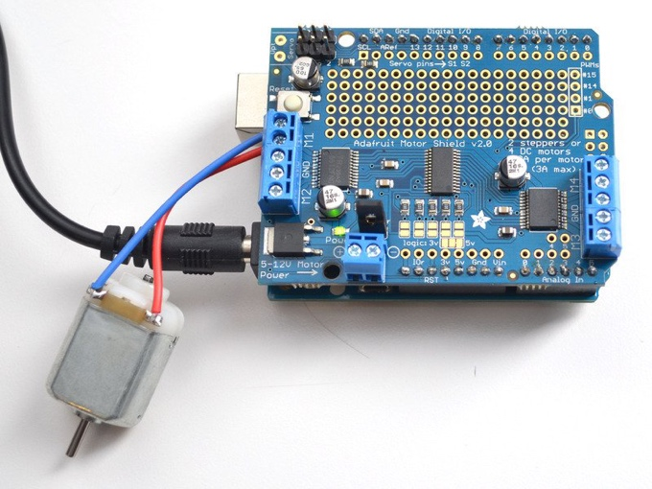
  - Supply 5 – 12 V DC to power the motor, using one of two methods.
    - Use the DC barrel jack to power the Arduino. Insert the VIN jumper (shown as the tall black handle right next to the green power LED in the photo below).
-or-
    - Use the DC barrel jack or USB port to power the Arduino, then use the 5 – 12 V DC motor power terminal port (shown as the double terminal block next to the green power LED) to power the shield. Remove the VIN jumper.
Tip: If the green power LED next to the power terminal block isn't brightly lit, do NOT continue!

  - After verifying that the motor is connected properly with the power LED brightly lit, upload the DC motor test code.
    - In the IDE, load File -> Examples -> Adafruit_MotorShield -> DCMotorTest
Tip: You should see and hear the DC motor turn on and move back and forth. If they have trouble seeing the movement, attaching a slip of paper or tape can help them visualize it.
- Stepper motor test

  - Restart the IDE to make sure the new library is loaded.
  - Plug the shield into the Arduino and connect a stepper motor to motor port 2. Tip: Note that, unlike DC motors, the wire order does matter.

  - Connect to the top two terminal ports (coil #1) and the bottom two terminal ports (coil #2).
    - For a bipolar motor, do not connect to the middle pin (GND).
    - For a unipolar motor with 5 wires, connect the common wire to GND.
    - For a unipolar motor with 6 wires, connect the two “center coil wires” together to GND.
  - Supply 5 – 12 V DC to power the motor, using one of two methods:

    - Use the DC barrel jack to power the Arduino. Insert the VIN jumper (shown as the tall black handle right next to the green power LED in the photo below).
-or-
    - Use the DC barrel jack or USB port to power the Arduino, then use the 5 – 12 V DC motor power terminal port (shown as the double terminal block next to the green power LED) to power the shield. Remove the VIN jumper.

Tip: If the green power LED next to the power terminal block isn't brightly lit, you should NOT continue!

  - After verifying that the motor is connected properly with the power LED lit up brightly, upload the stepper motor test code.
    - In the IDE, load File -> Examples -> Adafruit_MotorShield -> StepperTest
Tip: You should see and hear the stepper motor turn on and move back and forth. If they have trouble seeing the movement, attaching a slip of paper or tape can help them to visualize it. There are four ways to move a stepper, with varying speed, torque and smoothness tradeoffs. This example code will demonstrate all four.

IEEE Lesson Plan:
Making a Motor Shield

Student Worksheet: Reflection

Did you get your motor shield work?

What problem(s) did you encounter and how did you work through them?

Share any new insight(s) you may have had along the way?

IEEE Lesson Plan:
Making a Motor Shield

Teacher Resource:
Alignment to Curriculum Frameworks

This lesson touches the standards listed but not with equal level of alignment (meaning SOME elements of the standard may be addressed and in other cases ALL of it will be addressed). We would like your help to better improve our alignments. Please email us with your feedback at tryengieering@ieee.org.

Next Generation Science Standards (NGSS)
MS-PS2-3: Ask questions about data to determine the factors that affect the strength of electric and magnetic forces.

Common Core State Standards for Mathematics
CCSS MP2: Reason abstractly and quantitatively. Mathematically proficient students make sense of quantities and their relationships in problem situations.

ITEEA Standards for Technological Literacy – All Ages
Standard 3.2: Students will develop an understanding of the Nature of Technology and Society of the core concepts of technology.

CSTA Computer Science Standards
Algorithms & Programing
- Standard 2AP-13 Decompose problems and subproblems into parts to facilitate the design, implementation, and review of programs
- Standard 2AP-17 Systematically test and refine programs using a range of test cases.

ISTE Technology Standards for Students
ISTE Standards for Students
- Innovative Designer: Students use a variety of technologies within a design process to identify and solve problems by creating new, useful or imaginative solutions.
- Computational Thinker: Students develop and employ strategies for understanding and solving problems in ways that leverage the power of technological methods to develop and test solutions.

