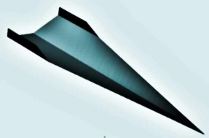
Take Flight!

Student Resource:
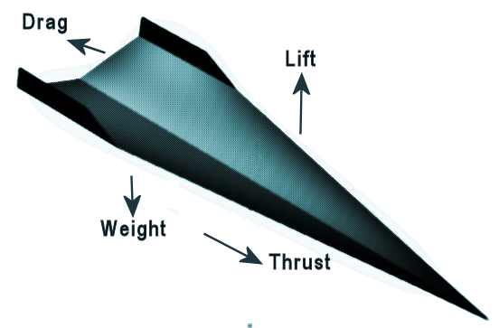
What Forces Impact Flight?

There are four forces that impact flight: Weight, Lift, Drag, and Thrust. All four forces have to be taken into consideration when designing and building a glider or airplane. In flight, each force has an opposite force that works against it.

Everything has weight, which is a result of gravitational forces. The materials selected for a glider design will have a weight that will need to be offset by “Lift” in order to fly.
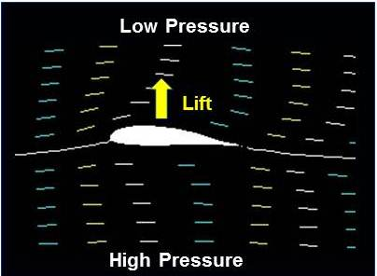
Lift is an aerodynamic force that helps to counteract weight. The heavier an object is, the harder it is for lift to work againt it and achieve flight. But, the forward motion (velocity) or thrust of an aircraft through the air along with the shape of the aircraft and its parts, especially its wings, all impact how strong the force of lift will be! Many wings have a curved shape on top and are flatter on the bottom so air moves faster over the top. When air moves faster, the pressure of the air decreases. If the pressure on the top of the wing is lower than the pressure on the bottom of the wing, the difference in pressure helps lifts the wing up into the air.
Image Credit: NASA

The last of the four forces impacting flight is drag….and this force works to slow a glider or plane. Drag is a force that acts opposite to the relative motion of any object moving with respect to surrounding air (or water!). For example, drag acts opposite to the direction of movement of a object such as a car, bicycle, airplane, glider, or boat hull. It is impacted by the shape and material selection of a plane or boat, as well as other factors, including the humidity of the air. It is also impacted by the the thrust or speed of the aircraft…the greater the thrust, the greater the drag.

In the case of the glider to be built as part of this lesson…the thrust is generated by the person who will push your plane through the air during testing! For a motorized plane, it is the motor that provides propulsion and the power to move through the air. A plane may have several motors to generate thrust, and the design of the motor also impacts how the surrounding air is moved, which in turn impacts thrust and drag.

All the forces impacting flight are interrelated. How a plane flies depends on the strength and direction of all four forces! If all are in balance, a plane will move along at a constant velocity. If there are any imbalances, the plane will move in the direction of that force…for example if weight overpowers lift, the plane will move down.

A plane goes up if the forces of lift and thrust are stronger than gravity and drag. If gravity and drag are stronger than lift and thrust, the plane goes down.

Take Flight!

Student Resource:
The Wright Brothers
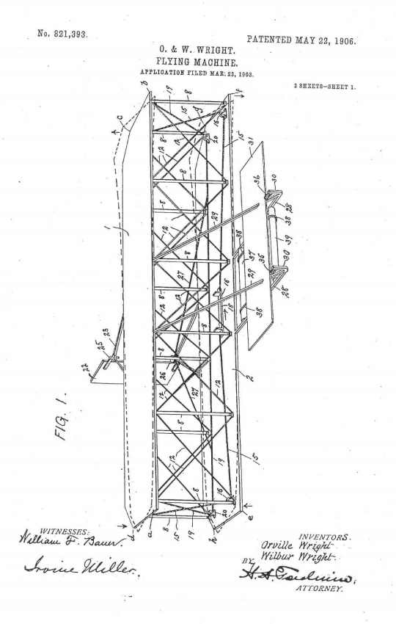
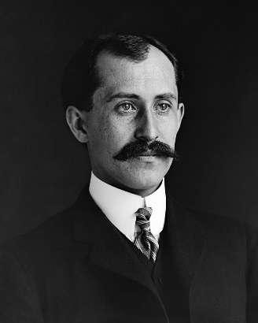
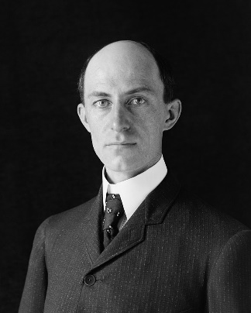
Orville Wright (August 19, 1871 – January 30, 1948, left) and Wilbur Wright (April 16, 1867 – May 30, 1912, right), were two brothers and aviation pioneers who are generally credited with inventing, building, and flying the world's first successful airplane. They made the first controlled, sustained flight of a powered, heavier-than-air aircraft on December 17, 1903, near Kitty Hawk, North Carolina, US. In 1904–05 the brothers further developed their flying machine into the first practical fixed-wing aircraft. Although not the first to build and fly experimental aircraft, the Wright Brothers were the first to invent and fine tune aircraft controls that made fixed-wing powered flight possible.
The brothers' real breakthrough was their invention of three-axis control – this enabled a pilot to steer the aircraft and maintain equilibrium, or balance. This method still remains the standard for all kinds of fixed-wing aircrafts. While others of the era were focusing on making more powerful engines, the Wright brothers thought that finding a way to control an aircraft was the more pressing challenge.
Using a small homebuilt wind tunnel, the brothers tested and retested their ideas and designs. They collected lots of data that helped them design and build more efficient wings and propellers that could be controlled. Their first U.S. patent, 821,393, (see right) did not claim invention of a flying machine, but rather, the invention of a “system of aerodynamic control that manipulated a flying machine's surfaces.”
They gained the experience and skills essential for their success by working with printing presses, bicycles, motors, and other machines. Their work with bicycles in particular influenced their belief that an unstable vehicle like a flying machine could actually be controlled and balanced with practice! From 1900 until their first powered flights in late 1903, they conducted extensive glider tests that also developed their skills as pilots.

More details on the Invention Process of the Wright Brothers can be found at https://wright.nasa.gov/overview.htm.

Take Flight!

Student Worksheet:

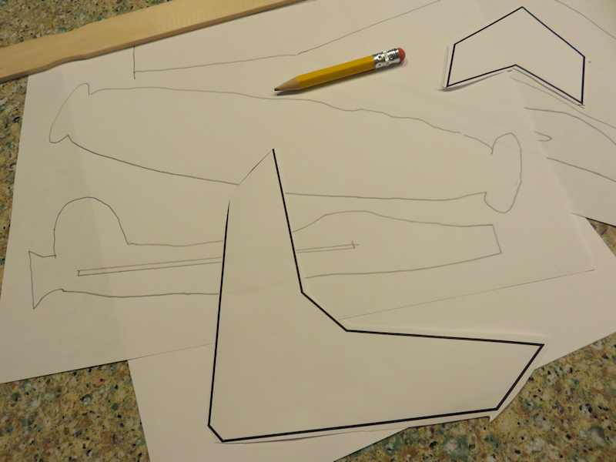
Engineering Teamwork and Planning
You are a team of engineers given the challenge of creating a glider out of simple materials that can fly as straight as possible toward a target that is fifteen feet away. You may use any materials provided to you and will first work as a team to develop a template for your glider.

Planning and Design Phase
Be sure to read the summary sheet about the forces that impact flight. It its simplest form, a glider can be considered to have three parts: the wings, the body (or fusilage), and the tail. The size, shape, materials, and weight of each will impact how well the glider will fly. Some gliders have a stabilizer on the tail or extra weight in the front to improve stability You can experiment with different materials to see what works best for your design.

Your team has been provided with a set of materials. Review these as a group and draw a simple design for each part of your glider in the box below. Please also include a list of materials you think you'll need to build your glider. Then draw a full size template of your parts which can be used to cut and build your actual glider.

Materials Required for Building:

Take Flight!

Student Worksheet

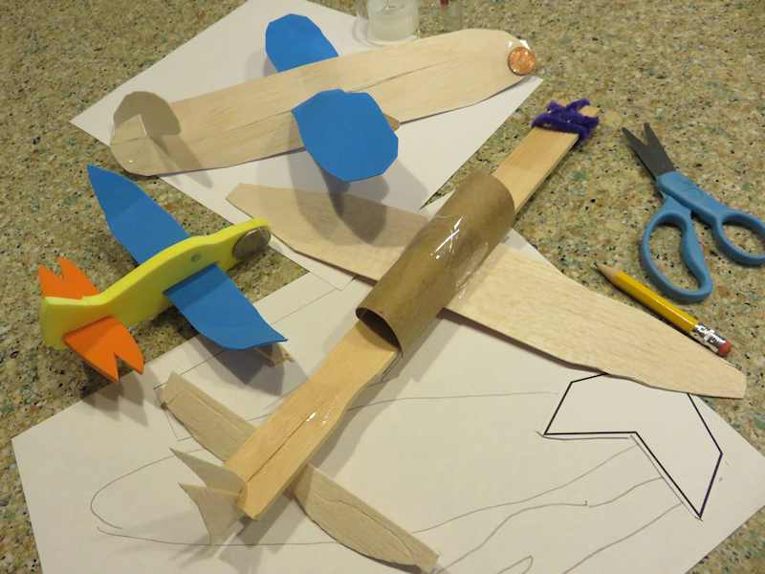
Construction Phase
Gather your materials, review your plan, and build your glider. Your team can change its design in the building stage, if necessary, to improve the final result. Then, answer the questions below:

1. How similar was your final glider to your original design template?

2. If you found you needed to make changes during the construction phase, describe why your team decided to make revisions.

3. Did you find you needed to add additional materials during construction? What did you add, and why?

4. Do you think that engineers often change their original plans during the manufacturing phase of development? How do you think this might impact a planned design or manufacturing budget?

5. How did you decide which materials to select for final construction? What was it about the materials that you thought might help your glider fly?

6. How did you decide on the shape of the parts of your glider? What was it about the shape of each part that you thought might help your glider fly?

Take Flight!

Student Worksheet (continued):
Flight Test Phase
Your teacher will test each glider three times to maintain consistency in the launch thrust. For your glider, indicate the distance flown and draw the flight path of each test in the boxes below:

Example:

Distance Flown: 5 feet

Flight Path: Our flight curved to the left, missing target (X)
end

start
X

Test One:

Distance Flown:

Flight Path:

Test Two:

Distance Flown:

Flight Path:

Test Three:

Distance Flown:

Flight Path:

Take Flight!

Student Worksheet (continued):
Evaluation
Complete the evaluation questions below:

1. What aspect(s) of the design led to the success of the glider that flew the straightest and furthest?

2. What was the best aspect of your design? Describe one part of your design that you think worked the best.

3. If you had a chance to do this project again, what would your team do differently?

4. If you could have selected some building materials which were not made available to you, what would you have selected? Why?

5. Do you think this project worked better because you were part of a team, or do you think you could have done a better job working alone?

6. Do you think that engineers work alone, or in a team when they are developing new materials, processes, or products?

7. If your glider was scaled up in size to be the length of an average passenger car, how far do you think it would have flown?

