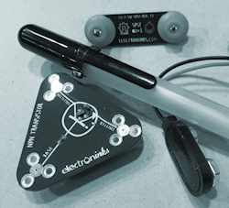 **Sketching Circuits**

**Student Resource:**

**What is a Simple Circuit?**

**◆ Simple Circuit**

A simple circuit consists of three elements: a source of electricity (battery), a path or conductor on which electricity flows (wire) and an electrical load (lamp) which is any device that requires electricity to operate. The illustration below shows a simple circuit containing a battery, two wires, and a low voltage light bulb. The flow of electricity is caused by excess electrons on the negative end of the battery flowing toward the positive end, or terminal, of the battery. When the circuit is complete, electrons flow from the negative terminal through the wire conductor, then through the bulb (lighting it up), and finally back to the positive terminal - in a continual flow.



**◆ Schematic Diagram of a Simple Circuit**

The following is a schematic diagram of the simple circuit showing the electronic symbols for the battery, switch, and bulb.



 **Sketching Circuits**

**Student Resource:**

**What Are Conductors and Insulators?**

**◆ Conductors/Conductivity**

Conductivity is the ability or power to conduct or transmit heat, electricity, or sound.

Conductors are materials that electricity easily passes through, that do not resist the flow of electricity. Examples are copper, aluminum, steel, silver, gold, electrolytes. Not all materials conduct electricity equally well.

**◆ Insulators**Insulators are materials that resist the flow of electricity, so electricity does not easily pass through. Examples are plastic, wood, rubber, cloth, air, glass. Some materials are better electricity insulators than others.

**◆ Challenge**Do you think the following items are more likely conductors or insulators?

|  |  |  |
| --- | --- | --- |
| **Eraser**  Conductor Insulator | **Aluminum Foil**  Conductor Insulator | **Rubber Bands**  Conductor Insulator |
| **Pencil/Graphite**  Conductor Insulator | **Paper Clips**  Conductor Insulator | **Plastic Caps**  Conductor Insulator |
| **Coins**  Conductor Insulator | **Cork**  Conductor Insulator | **Keys**  Conductor Insulator |

 **Sketching Circuits**

**Student Resource:**

**What are LEDs?**

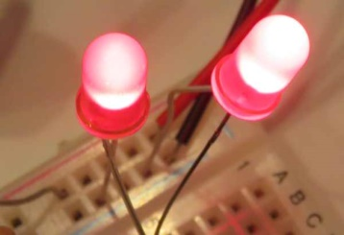A Light-Emitting Diode – or LED -- is a semiconductor device built to emit light when activated. Different chemicals give different LEDs their colors.  When powered at the proper level, they can last much longer than incandescent lightbulbs and do not break easily. They can display many different colors, can be very small, and are extremely efficient. Most of the energy they consume makes light, not heat. Most LEDs are very small, less than 1 mm, and so can be integrated in to many products.

**◆History**

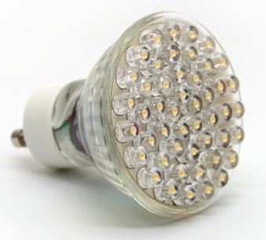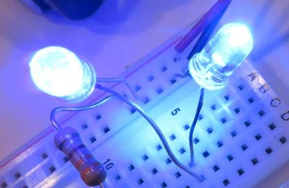The first visible-spectrum (red) LED was developed in 1962 by Nick Holonyak, Jr. while working at General Electric. In 1972, M. George Craford, a former graduate student of Holonyak, invented the first yellow LED and improved the brightness of red and red-orange LEDs by a factor of ten. In 2014, the Nobel Prize in Physics was awarded to a team of scientists (Isamu Akasaki, Hiroshi Amano, and Shuji Nakamura) “for the invention of efficient blue light-emitting diodes which has enabled bright and energy-saving white light sources" While red and green LEDs had been available for many years at that time, the blue LEDs were a big challenge for scientists and engineers around the world. The blue version was needed to be able to mix with the red and green ones to produce white light…without white light we would not have had LED-based computer and TV screens.

**◆Color and Shape Selection**

LEDs are produced many shapes and sizes, and while the color of the plastic lens is usually the same color as the light emitted, this is not always true. Many blue LEDs actually have clear or colorless plastic lenses, like the one to the right.

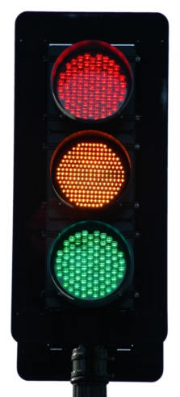**◆Applications**

At first, LEDs were used as indicator lamps for simple electronic devices, where they replaced small incandescent bulbs and allowed products to be smaller. They were soon popularized and used in digital clocks and calculators. Quickly, manufacturers and consumers found that the small size and efficiency of these little lights made them the perfect choice for many applications. As an example, a white LED lightbulb converts over 50% of the electricity it uses into light…an incandescent bulb only converts about 4% into light. So now the applications are widespread…from car headlamps and taillights, camera flashes, and computer and television screens. If you look closely at your local traffic lights, you may find that what looks like a big bulb from a distance is actually a round pattern of red, green and yellow LEDs!

 **Sketching Circuits**

**Student Worksheet:**

**◆ Planning**

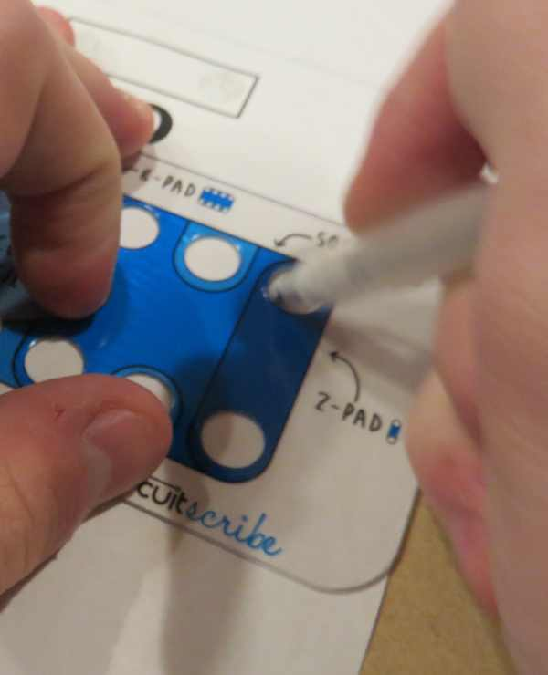

You and your team will be creating a simple circuit using a conductive pen instead of wiring. Because the paper can be folded, you have the opportunity to be very creative! You may use the separate worksheet to build your own voting station…or come up with your own idea that incorporates two LEDs and allows for someone to interact with your circuit. You may be creative and draw a flower that lights up, set up an interactive quiz, or anything which lights up two LEDs. You should conserve the special pen for lines that require current to flow and other drawing tools like colored pencils, crayons, or markers for other decorations.

In the box below, draw with a normal pencil your planned circuit --- you will want to save the special pen for the final version. Be sure to mark where your battery and LED will be placed and consider any folding you might need to factor into the design. You can use the following electronic symbols in your sketch:

LED: 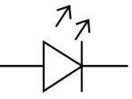 Battery: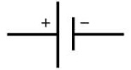

You can use the template that comes with your kit to draw the circles to match the magnetic base of each component.

Once your teacher approves the planned design your team may move on to construction!

|  |
| --- |
|  |

 **Sketching Circuits**

**Student Worksheet:**

**◆ Drawing, Building, and Testing**

Using your approved pencil sketch as a plan, create your paper circuit. Remember to use the circuit pen only for lines necessary to carry current and use other drawing tools for any instructions, decorations, or other writing needed.

Once complete, answer the following questions:

1. Did you need to redesign your original pencil plan prior to building your final circuit? If so, what changed?

2. Do you think that drawing a circuit is easier than working with wires? Are there any reasons why you think a wire circuit would be more appropriate?

3. Describe a design that another student team developed that you thought was particularly creative!

4. How do you think paper circuits might be used in everyday life? Would this be a new product, or adapting or improving an existing product?

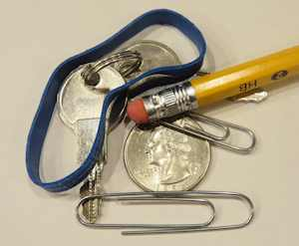**◆ Conductive Material Test**

Now that you’ve built a simple circuit, try building a circuit that could be used to test a range of materials (provided to you) for conductivity. With an LED included in your testing circuit you will be able to see if a material is a conductor if it lights up!

As before, in the box below, draw with a normal pencil your planned conductive testing circuit. Once your teacher approves the planned design your team may build it.

|  |
| --- |
|  |

 **Sketching Circuits**

**Student Worksheet:**

**◆ Conductive Testing**

In the box below, document the materials you examined in your conductive test circuit, and include your results.

|  |  |  |
| --- | --- | --- |
| Material Tested | Insulator or Conductor | Observations |
|  |  |  |
|  |  |  |
|  |  |  |
|  |  |  |
|  |  |  |
|  |  |  |
|  |  |  |
|  |  |  |

**◆ Review and Reflections**

1. Were you able to create a circuit that could test for conductivity?

2. Were there any materials that you tested that surprised you?

3. Why is it important to know whether a material is an insulator or a conductor?

 **Sketching Circuits**

**Student Voting Worksheet:**



**YES NO**

 **Sketching Circuits**

**For Teachers:**

**Sample Solution Voting Template**



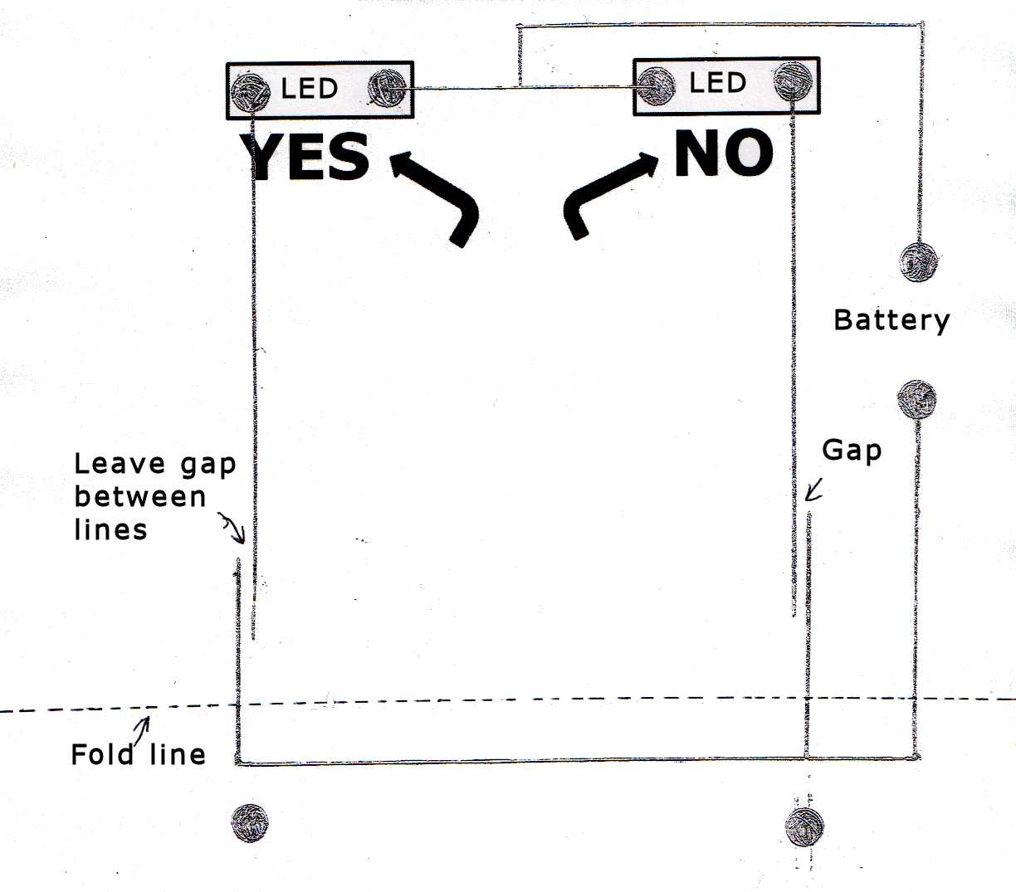

 **Sketching Circuits**

**For Teachers:**

**Sample Solution Voting Photos**



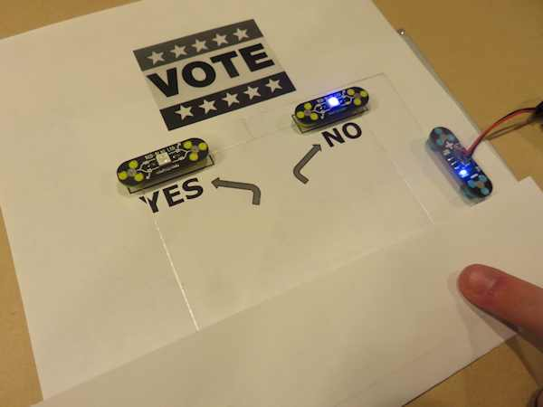

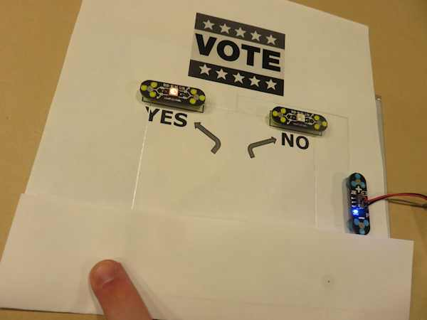

**Sketching Circuits**

**For Teachers:**

**Sample Solution Testing Template**

The following is just a simple sample of how a testing template could be drawn for this lesson. Encourage students to come up with their own design and be creative.

